Question 4.0 display manager_id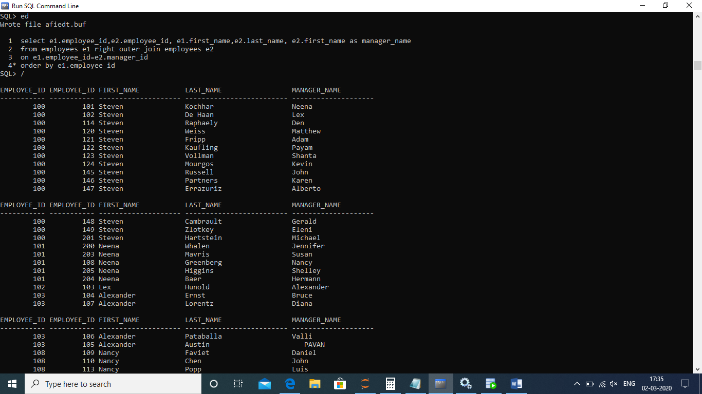

Question 2.Salary of member greater than avg of other meember of dept 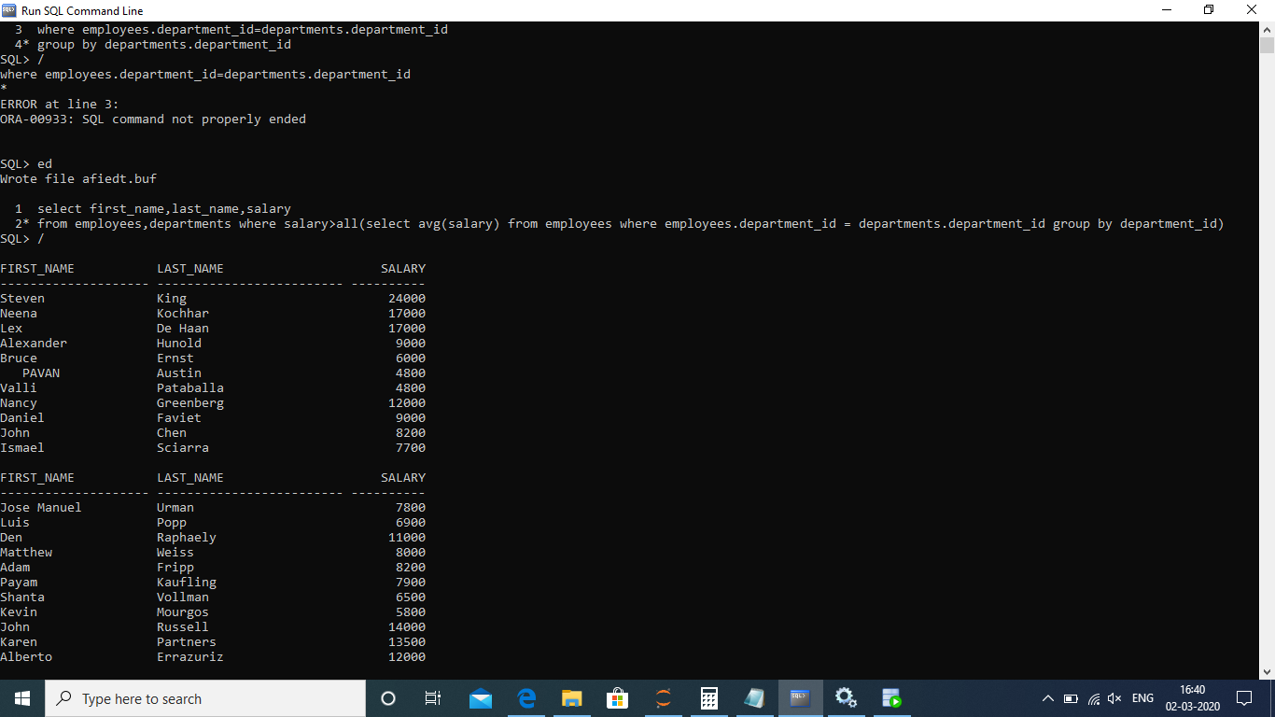Question1. Question 1.Salary more than 20 members 

Question 3:Difference of salary

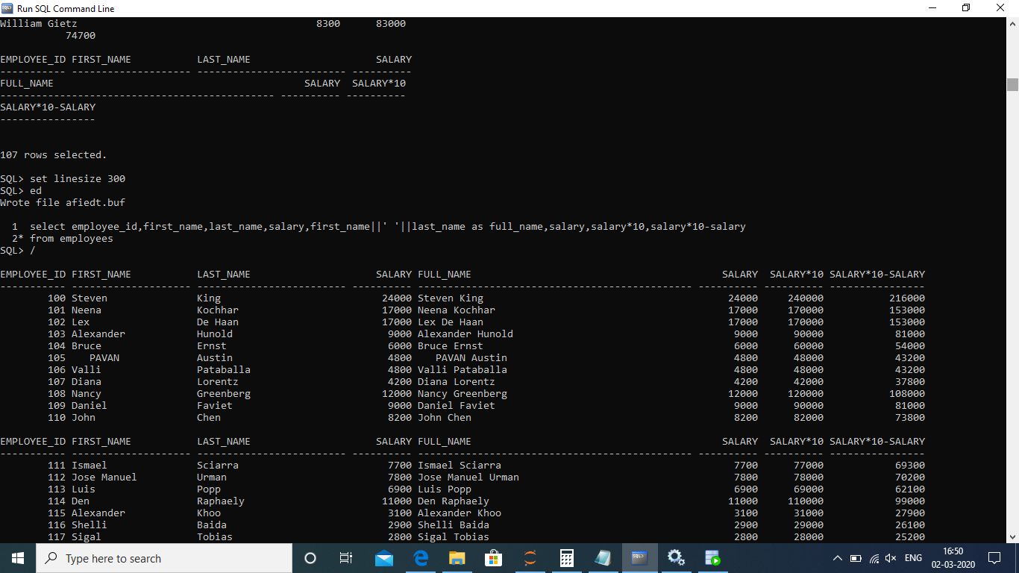

Question 5:top three salaries

